**BANK LOAN REPORT QUERY DOCUMENT**

1. **BANK LOAN REPORT | SUMMARY**

**KPI’s:**

**Total Loan Applications:**

select count(id) as Total_Loan_Application from financial_loan



MTD Loan Applications:

select count(id) as MTD_Total_Loan_Application from financial_loan

where month(issue_date) = 12 AND year(issue_date) = 2021



**PMTD Loan Applications:**

select count(id) as PMTD_Total_Loan_Application from financial_loan

where month(issue_date) = 11 AND year(issue_date) = 2021

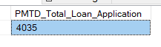

__________________________________________________________________________________

**Total Funded Amount:**

select sum(loan_amount) as Total_Funded_Amount from financial_loan



MTD Total funded Amount:

select sum(loan_amount) as MTD_Total_Funded_Application from financial_loan

where month(issue_date) = 12 AND year(issue_date) = 2021



PMTD Total Funded Amount:

select sum(loan_amount) as PMTD_Total_Funded_Application from financial_loan

where month(issue_date) = 11 AND year(issue_date) = 2021



__________________________________________________________________________________

**Total Amount Received:**

select sum(total_payment) as Total_Amount_Amount from financial_loan



MTD Total Amount:

select sum(total_payment) as MTD_Total_Amount from financial_loan

where month(issue_date) = 12 AND year(issue_date) = 2021



PMTD Total Amount:

select sum(total_payment) as PMTD_Total_Amount from financial_loan

where month(issue_date) = 11 AND year(issue_date) = 2021



__________________________________________________________________________________

**Average Interest Rate:**

select avg(int_rate)*100 as Avg_Int_Rate from financial_loan



MTD Avg_Int_Rate:

select avg(int_rate)*100 as MTD_Total_Amount from financial_loan

where month(issue_date) = 12 AND year(issue_date) = 2021



PMTD Avg_Int_Rate:

select avg(int_rate)*100 as PMTD_Total_Amount from financial_loan

where month(issue_date) = 11 AND year(issue_date) = 2021



__________________________________________________________________________________

**Average Debt-to-Income Ratio (DTI):**

select avg(dti)*100 as Avg_DTI from financial_loan



MTD Avg_DTI:

select avg(dti)*100 as MTD_Avg_DTI from financial_loan

where month(issue_date) = 12



PMTD Avg_DTI:

select avg(dti)*100 as PMTD_Avg_DTI from financial_loan

where month(issue_date) = 11



__________________________________________________________________________________

**GOOD LOAN ISSUED**

**Good Loan Percentage**

SELECT

(COUNT(CASE WHEN loan_status IN ('fully paid', 'current') THEN id END) * 100.0)

/ COUNT(*) AS good_loan_percentage FROM financial_loan;



**Good Loan Application:**

SELECT COUNT(id) AS good_loan_applications FROM financial_loan

WHERE loan_status IN ('fully paid', 'current');



**Good Loan Funded Amount:**

SELECT SUM(loan_amount) AS good_loan_funded_amount

FROM financial_loan

WHERE loan_status IN ('fully paid', 'current');



**Good Loan Total Received Amount:**

SELECT SUM(total_payment) AS good_loan_received_amount

FROM financial_loan

WHERE loan_status IN ('fully paid', 'current');



__________________________________________________________________________________

**BAD LOAN ISSUED**

**Bad Loan Percentage**

SELECT (COUNT(CASE WHEN loan_status = 'Charged off' THEN id END) * 100.0)

/ COUNT(id) AS bad_loan_percentage

FROM financial_loan;



**Bad Loan Applications**

SELECT COUNT(id) AS bad_loan_applications

FROM financial_loan

WHERE loan_status = 'Charged off';



**Bad Loan Funded Amount**

SELECT SUM(loan_amount) AS bad_loan_funded_amount

FROM financial_loan

WHERE loan_status = 'Charged off';



**Bad Loan Amount Received**

SELECT SUM(total_payment) AS bad_loan_funded_amount

FROM financial_loan

WHERE loan_status = 'Charged off';

****__________________________________________________________________________________

**LOAN STATUS**

SELECT loan_status AS Loan_Status,

COUNT(id) AS Total_Loan_Applications,

SUM(loan_amount) AS Total_Funded_Amount,

SUM(total_payment) AS Total_Amount_Received,

AVG(int_rate*100) AS Average_Interest_Rate,

AVG(dti*100) AS Average_DTI_Ratio

FROM financial_loan

GROUP BY Loan_Status;

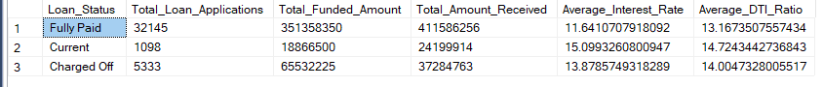

SELECT loan_status,

SUM(total_payment) AS MTD_Total_Amount_Received,

SUM(loan_amount) AS MTD_Total_Funded_Amount

FROM financial_loan

WHERE MONTH(issue_date) = 12

GROUP BY loan_status

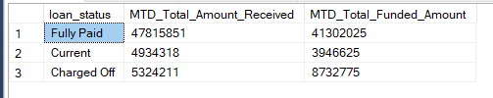

1. **BANK LOAN REPORT | OVERVIEW**

**MONTH**

SELECT

MONTH(issue_date) as Month_Number,

DATENAME(MONTH, issue_date) as Month_Name,

COUNT(id) AS Total_Loan_Applications,

SUM(loan_amount) AS Total_Funded_Amount,

SUM(total_payment) AS Total_Amount_Received

FROM financial_loan

GROUP BY MONTH(issue_date), DATENAME(MONTH, issue_date)

ORDER BY MONTH(issue_date);

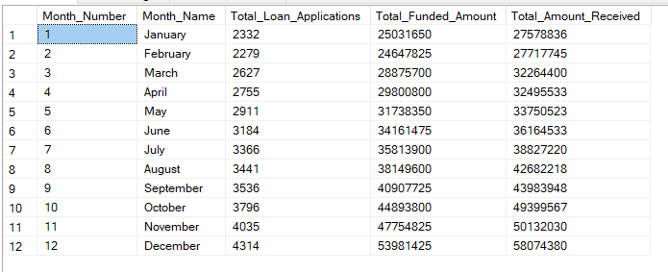

**STATE**

SELECT

address_state AS State,

COUNT(id) AS Total_Loan_Applications,

SUM(loan_amount) AS Total_Funded_Amount,

SUM(total_payment) AS Total_Amount_Received

FROM bank_loan_data

GROUP BY address_state

ORDER BY address_state

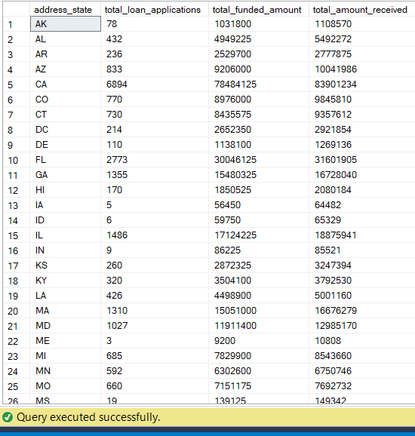

**TERM**

SELECT

term as Term,

COUNT(id) AS total_loan_applications,

SUM(loan_amount) AS total_funded_amount,

SUM(total_payment) AS total_amount_received

FROM financial_loan

GROUP BY term

ORDER BY term;

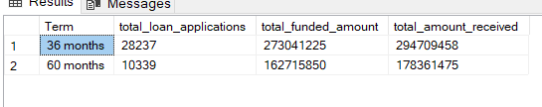

**EMPLOYEE LENGTH**

SELECT

emp_length,

COUNT(id) AS total_loan_applications,

SUM(loan_amount) AS total_funded_amount,

SUM(total_payment) AS total_amount_received

FROM

financial_loan

GROUP BY emp_length

ORDER BY emp_length;

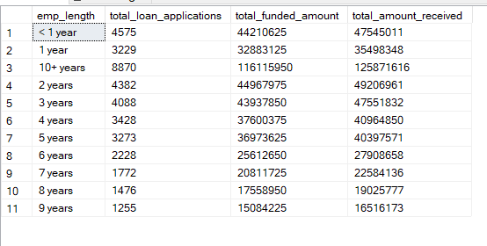

**PURPOSE**

SELECT

purpose as Purpose,

COUNT(id) AS total_loan_applications,

SUM(loan_amount) AS total_funded_amount,

SUM(total_payment) AS total_amount_received

FROM

financial_loan

GROUP BY purpose

ORDER BY purpose;

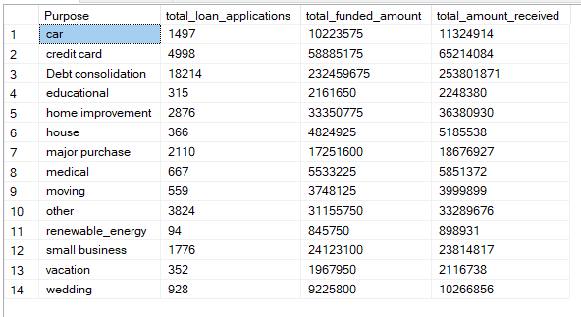

**HOME OWNERSHIP**

SELECT

home_ownership as Home_OwnerShip,

COUNT(id) AS total_loan_applications,

SUM(loan_amount) AS total_funded_amount,

SUM(total_payment) AS total_amount_received

FROM financial_loan

GROUP BY home_ownership

ORDER BY home_ownership;

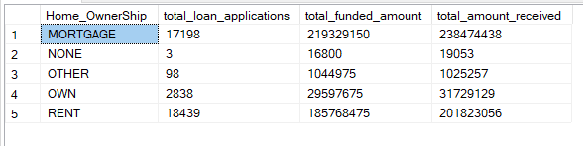

*Note: We have applied multiple Filters on all the dashboards. You can check the results for the filters as well by modifying the query and comparing the results.*

*For e.g*

*See the results when we hit the Grade A in the filters for dashboards.*

*SELECT*

*purpose AS PURPOSE,*

*COUNT(id) AS Total_Loan_Applications,*

*SUM(loan_amount) AS Total_Funded_Amount,*

*SUM(total_payment) AS Total_Amount_Received*

*FROM bank_loan_data*

*WHERE grade = 'A'*

*GROUP BY purpose*

*ORDER BY purpose*

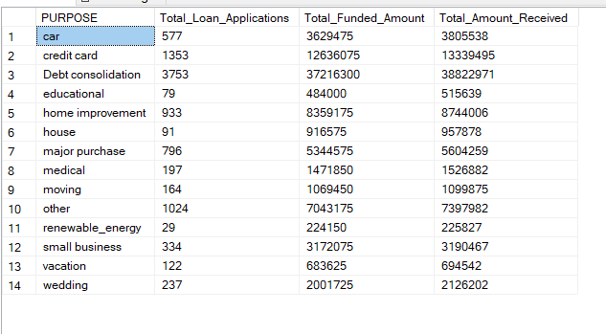

MTD:

MTD Amount Received = CALCULATE(TOTALMTD([Total Amount Received],'Date Table'[Date]))

PMTD:

PMTD Total Funded Amount = CALCULATE([Total Funded Amount],DATESMTD(DATEADD('Date Table'[Date],-1,MONTH)))

MOM:

MOM Loan Application = ([MTD Loan Applications]-[PMTD Loan Applications])/[PMTD Loan Applications]

Total:

Total Funded Amount = SUM(financial_loan[loan_amount])